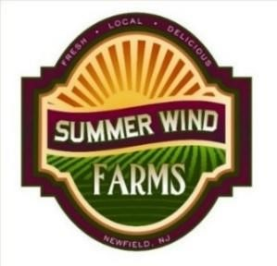
Summer Wind Farms, LLC
Community Supported Agriculture (CSA)
MEMBERSHIP REGISTRATION AND CONTRACT FORM 2024

Please register me as a member of Summer Wind Farm’s Community Supported Agriculture (CSA) program for the summer 2024 growing season.

I understand that farming is a seasonal and unpredictable business that may have unforeseen risks, and the exact selections and quantities included in the weekly harvest will change as the season moves forward. In joining the CSA, I understand and agree to share in the changes and variations normal in farming and for reasons beyond the control of Summer Wind Farms LLC.
Name: _________________________________________________
Choose your pickup location:
___ The Farm, Wednesdays
___ Dutch Wagon Market, Medford, Fridays
___ Dutch Wagon Market, Medford Saturdays
___ Halo Wellness Center, Marlton, Fridays (not for Fall shares)

Address: _______________________________________________

City/State/Zip: __________________________________________

Email: _________________________________________________

Cell Phone: _____________________________________________
Alternate Pick-Up Person: _________________________________
Alternate's Cell Phone: ___________________________________

QTY. Vegetable Share Pick Up Location |  | Cost | EXT.
____ Organic Farm Share, about 17 weeks |  | $475.00 | __________
____ Organic Mini Farm Share, about 17 weeks |  | $315.00 | __________
____ Jersey Summer Fruit Share, about 13 weeks |  | $315.00 | __________
____ Fall Farm Share, 7 weeks |  | $215.00 | __________
____ Jersey Summer Flower Share, every two weeks, +/- 6 shares |  | $120.00 | __________
 |  | Sub Total | __________
Discounts, 2% for buying any two or more shares, 4% for three or more and 6% for buying four or m0re shares. Multi share discount only applies to paid in full purchases. |  | Discount
 |  | Total | __________
I have read and understand this contract as well as having read the details of the CSA program on the farm's web site, especially the “frequently asked questions” section. I agree with the terms and conditions of the Summer Wind Farms, LLC CSA program. Visit www.summerwindfarms.com.
______________________________________________________________________________________
Signature Date Amount Paid /How Paid
Please enclose this form with a check or money order payable to Summer Wind Farms, LLC or visit www.summerwindfarms.com to make a credit card payment.
Summer Wind Farms, LLC 3366 Victoria Ave. Newfield, NJ 08344 summerwindfarmsCSA@gmail.com

